 | Assignment No. 02  Semester: Fall 2023  CS408 – Human Computer Interaction  Question File | Total Marks: 20  Due Date: 12-01-2024
Instructions
Please read the following instructions carefully before submitting assignment:
It should be clear that your assignment will not get any credit if:

- Assignment is submitted after due date.
- Submitted assignment does not open or file is corrupt.
- Assignment is copied (From internet/students).
Objectives:
The objective of this assignment is to:

- Enables you to understand low and high-fidelity prototypes

- Enables you to understand their advantages and disadvantages

Assignment Submission Instructions
It’s required to submit only MS Word document file on the Assignments interface of CS408 at VULMS. Assignment submitted in any other format (like pdf, image file or etc.) will not be accepted and will be graded zero marks.

For any query about the assignment, contact through email at cs408@vu.edu.pk

….……*****……….

Question No. 1

There are two images in the below mentioned table. Identify that which one of the following is a Low-Fidelity Prototype and which one is a High-Fidelity Prototype and write your answer in the column named “Type”. Also give the justification in column named “Justification”.

Note: Justification should be to-the point. No long stories required.
Sr# | Image | Type | Justification
1 | 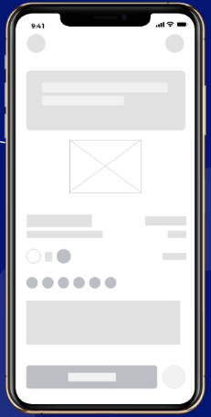
2 | 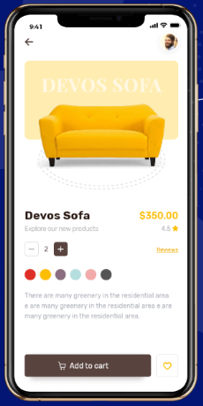

Question No. 2

As you studied about several advantages and disadvantages of low and high-fidelity prototypes. There are some statements in the column named “Statements” in the below mentioned table. These are the advantages and disadvantages of low and high-fidelity prototypes. You are required just write advantage or disadvantage word towards each statement in the column named “Advantage/Disadvantage”.
Sr# | Type | Statements | Advantage/Disadvantage
1 | Low-fidelity prototype | Evaluate multiple design concepts.
1 | Low-fidelity prototype | Address screen layout issues.
1 | Low-fidelity prototype | Limited utility after requirements established.
2 | High-fidelity prototype | Time-consuming to create.
2 | High-fidelity prototype | Look and feel of final product.

.………*****……….

Best of Luck ☺
Deadline:
Assignment is covering the content till Lecture# 24. The deadline to submit your assignment is January 12, 2024.

